Week 2

Submitted by: ABHISHEK SINGH

Reg. No.: RA1711003010827

Aim: Design a web page with an attractive background

color, text color, an Image, font etc. (use internal CSS)

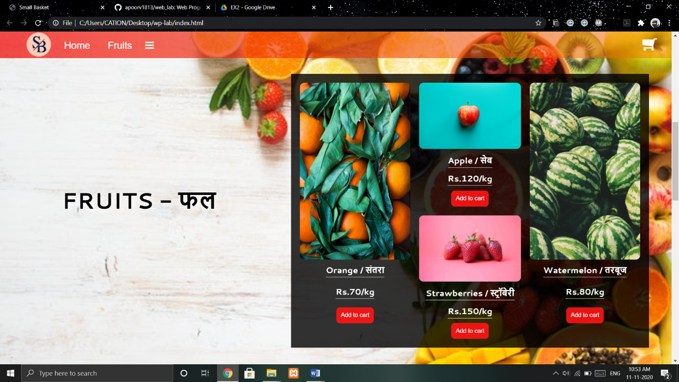

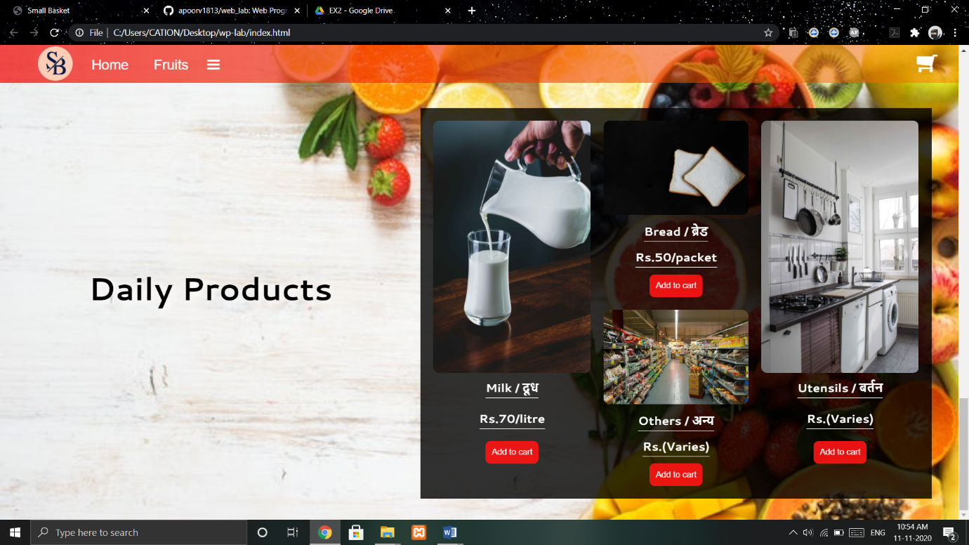

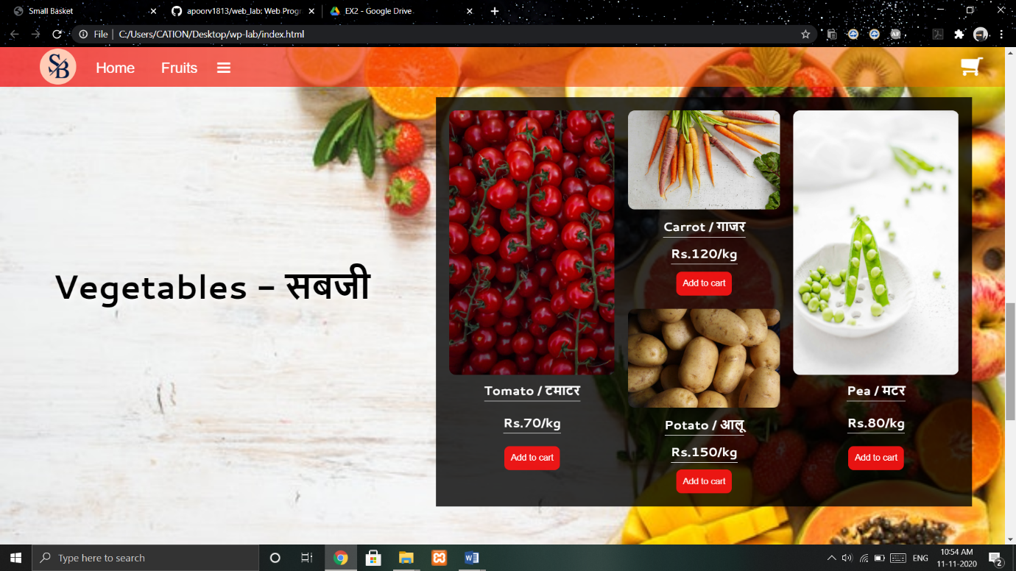

Work done:

Inserted background image, changed background colour, text

colour using CSS. Added anchor tags to other pages.